|  |  |
| --- | --- |
| **HEAD OF SCHOOL SEARCH**  **GORDON SCHOOL**  Providence, RI  https://www.gordonschool.org/  Start Date: July 2026 |  |

|  |
| --- |
|  |

**Mission Statement**

Child by child, the Gordon School community cultivates successful students by inspiring joyful learning, encouraging intellectual leadership, fostering an empathic spirit and stimulating a drive for positive societal impact.

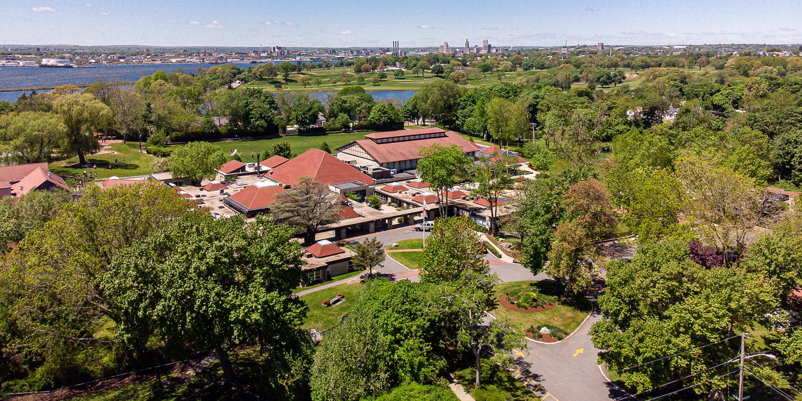

**Overview**

Gordon School, located in Providence, Rhode Island, offers a unique, dynamic educational environment inspired by nature. We passionately uphold our roots as a community-spirited institution, committed to evolving and accommodating our students' needs whilst staying true to our identity. Our tradition of inclusive education stems from our cherished principles of diversity, equity, and social justice work. Founded with a social-emotional learning approach, Gordon School promotes a joyful child-centered learning experience that earns the school a notable reputation in the region.  
  
At Gordon School, students are placed at the heart of their education. We offer them the opportunity to delve into creative and interconnected faculty systems that prioritize their individualized learning process. Our concise size allows us to be nimble: 350-380 students encompass our community of learners. With our coveted tuition program and progressive DEI efforts setting us apart from public schools, Gordon School educates the whole child and nurtures them into mature, capable members of society, skilled in engaging with complex topics and ideas.  
  
As for our leadership, the upcoming vacancy of the Head of School presents a thrilling period for Gordon School. With an ambitious working goal of $17.5M targeted principally for endowment and campus expansion (including the development of a new middle school), Gordon is set for considerable growth and transformation. The new Head will play a significant role in elevating the school’s profile nationally and regionally, fostering our community spirit, and continuing our dedication to diversity, equity, and social justice. Naturally, we're eager to welcome a leader who's accessible, visible, passionate about young learners, and possesses a keen ability to demonstrate the value of a Gordon School education.

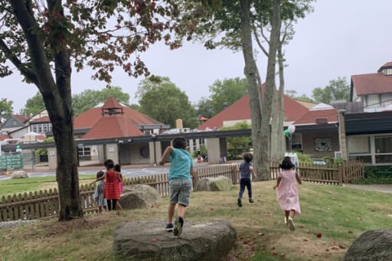

**Opportunities and Challenges**

Gordon School, with its esteemed leadership team, committed faculty, and rich culture of diversity, equity, and inclusion (DEI), is ready for its next dynamic stage. The school’s unique ability to seamlessly combine joyful learning, nature-inspired education, social-emotional learning, and community-centred development warrants a leader ready to uphold these values, while also embracing opportunities for future growth.  
  
**Key opportunities and challenges include:**

• Enhancing school reputation and promoting the unique 'Gordon School' experience both regionally and nationally

• Addressing issues of revenue sustainability and launching new fundraising initiatives possibly linked to the planned campus master plan

• Balancing the progressive Lower School approach with a slightly more traditional Middle School one

• Enhancing the tuition model to ensure its continued efficiency and value

• Building out the learning support framework, with particular attention to students with learning differences and neurodiversity

• Investing in the Middle School to retain students through grade 7, with special focus on 'sporty' boys

• Developing a strategic approach to enrollment and retention to maintain the school’s optimal size

• Enhancing the visibility of the school leadership, fostering an open door policy, and furthering a culture of open and effective communication

• Furthering the school's longstanding commitment to DEI work by integrating it into school marketing and outreach efforts.

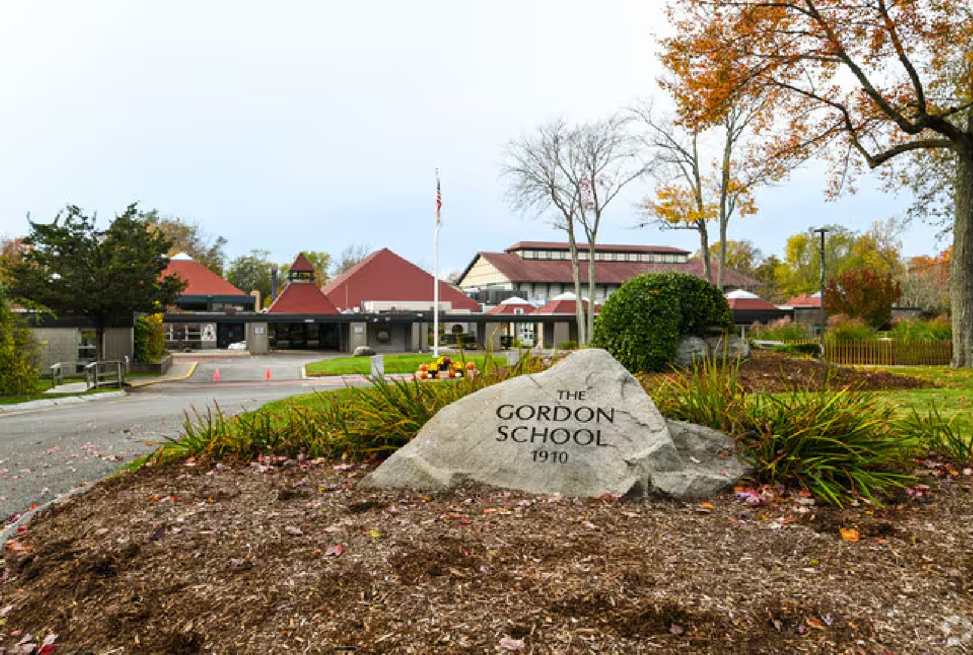

**Qualifications and Personal Attributes**

The next Head of School will be an engaged, dedicated, dynamic leader who embodies kindness, resilience, and imagination. Passionate about enriching young lives, they should be committed to the school's mission and enthusiastic about spearheading its next phase of growth, while fostering a culture of diversity, equity, and inclusion.

Preferred Qualifications for the successful candidate include:

• Extensive leadership experience in independent or international schools

• Proficiency in designing and implementing diversity, equity, and inclusion programs

• Strong engagement and presence within the school community

• Knowledgeable understanding of elementary and middle school curriculum development

• Proficiency in fostering positive relationships within a collegial atmosphere

• Successful track record in fundraising and maintaining school facilities and programs

• Demonstrable charisma and ability to inspire and engage an audience

• Commitment to promoting the school on a regional, national, and local level

• Capable of leading strategic initiatives for enrollment and student retention

• Exemplary communication skills for effective local and global outreach efforts

• Established ability to support students with diverse learning needs

• Demonstrable commitment to fostering a joyful, child-centered learning environment

• Advanced degree in Education or a related field, demonstrating personal commitment to professional growth.

**Learn More**

Click on the links below to learn more about Gordon School.

|  |  |
| --- | --- |
| [School Website](https://www.gordon.edu/) | [Town Information](https://www.providenceri.gov/) |
| [School History](https://www.gordonschool.org/about/mission) |  |

**To Apply**

Interested and qualified candidates are invited to contact the consultants in confidence. Candidates will ultimately need to submit the following materials as separate PDF documents:

• A cover letter expressing their interest in this particular position;

• A current résumé;

• A statement of educational and leadership philosophy;

• A list of five professional references with name, relationship, phone number, and email address of each (references will not be contacted without the candidate's permission) to:

**Jim Schwartz**

Consultant

js@csa.com